Enterprise Framework Project 2012.

Project Details.

Project : BookEasy

Team :
Dermot Healy. x11106522
Remi Fatus.
Simon Rahilly.
Clem Roberts.
1)Background research and investigations.

Websites
The research began by looking at various websites that offer holiday home or apartment letting. We recorded how the sites delivered the data to the user and what functionality they provided.

It was found that most of the sites provide the following main options:-
- List of apartments/ holiday homes available.
- Search of list.
- Sort by price, facilities etc.
- Photos of the area or apartment.
- Booking method.
- Forms used, information gathered

Next we looked at the various pages and what data we would need for each page.

The site would contain several pages Home, About, Owners and Holidayhomes.

We decided to implement a single page that lists all the holiday homes / apartments available, give the user the option to sort/filter the list and to be able to search the list. This page would need location of holiday home, cost, a reference number and contact details of the person renting the property.

The booking page would be called form the holiday home page. The booking page would require some personal and credit card details in order to book a holiday home / apartment.

Data Source
We searched for websites that we could get our test data from, either in CSV format or XML. While we found several sites that made hotel information available to other website we couldn’t find a free source of data. All the holiday home sites we looked provided a link to their site but you were required to sign a contract. It was then decided to create our own data in CSV format for this application .

Images
We looked at various picture websites and found a free source to get sample villa and apartment images to use throughout the website.

Frameworks
We looked at various sites that provided information on frameworks, ASP.NET, MVC2, MVC3, tutorials, design patterns etc. to try and get a handle on how to approach the design of the application.
.

2)Project Plan.

Code Development: Clement Roberts, Dermot Healy and Remi Fatus were assigned responsibility for coding the project.

Documentation: Simon Rahilly was assigned writing the project report.

Team name: DERESICL

GIT Hub Location: GITHUB.COM\DERESICL

Introduction:
We are to design and create a website that will serve as a holiday home booking system. The website will display Holiday Homes in a virtual storefront. Users will be able to create accounts, log in, browse the database of Holiday Homes and book a Holiday Home.

Goals:
The goal of the project is to have a functioning enterprise web application that can facilitate online bookings. The final developed application will be a user friendly site, with clear instructions on the steps to make a booking while also requiring authentication and providing security.

Strategy:
The web application will be developed using C# and ASP.net, the various stages of the project such as planning, design and development will be shared out equally among the team members.

Functionality:
When complete, the key characteristics of the application will be:
- Holiday home owners will be able to add details about their Holiday home.
- Authentication will be required for Owners when accessing their accounts on the site.
- Allow the customers to browse through a various locations and holiday homes.
- The virtual storefront will be connected to a backend database, which can be updated also.
The customer will get a communication to confirm their booking.

Project Deliverables:
- A working enterprise web application, as described above.
- A written technical report to supplement the application.
- A project log on GITHub detailing the development of all stages of the project.
- Presentation.

The team will develop a web application that handles holiday home bookings. The application will attempt to
- Maintain a database of holiday homes.
- Record vacancy/booked periods.
- Take bookings.
- Provide location of holiday homes.

3) Software development methodology employed.
We decided from day one to implement the Agile software development method. The application required a 5 tier architecture and the only way we could implement that was by building small units of code and maintaining constant contact with the other code developers. The code would be developed in parallel each person working on various sections such as the backend Database & DAL, the business logic and the presentation layer. It was deemed important that everyone should be working off the same version of code and to let each other know of changes implemented. With this in mind we used GIT hub as our repository for our code and any new version of the code were pushed up to it. The plan was to have the latest version of code on GIT and all coders pull from GIT to ensure they had the latest version. Emails would be sent to the developers as an extra reminder in case they forgot to pull down the latest version. We would also exchange the latest code when ever we met.
As we got to understand how Visual Studio and the Entity Framework worked we would change our code to meet the 5 tiers.

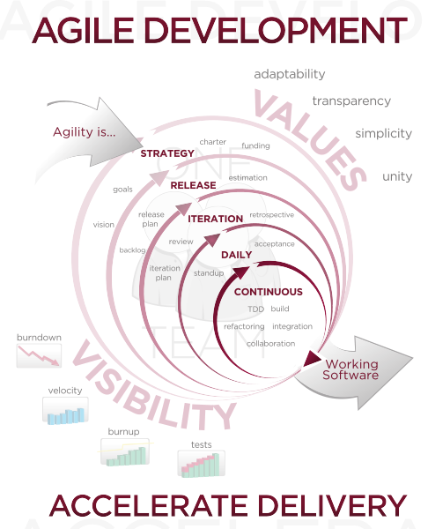
4) Requirements analysis.
A lot of the application requirements were gathered during early research and investigations.

Requirements analysis includes three types of activity
- Elicitation requirements.
- Analysing requirements.
- Recording requirements.

As the customer is fictitious in this case we discussed the requirements of what we would want from a holiday home website and used these requirements when developing the site. This resulted in us drawing up a list of basic requirements for the application.
We analysed the requirements and anything we needed in the project was implemented as there are no stakeholder to answer to.
Finally the requirements were recorded and documented in the report.

5) Use cases.
From our early investigations, research and requirement analysis we drew up a list of use cases for the application. The main criteria the application must cover are the following:-

A) Home Page:- Welcome to Book Easy.
B) About Page:- Who Book Easy are.
C) Owners Page.
D) Holiday Homes Page.
E) Booking Page. Subset of Holiday Home Page

Use case Descriptions

Welcome Page
The application takes the user to the home page. Our home page is our welcome page. This page welcomes the user to the site and tells them a little about what the site offers. It has 3 links to other pages, About, Owners and Holidayhomes.

About Page
This is a short descriptive page about the company Book Easy. It has 3 links to other pages, Home, Owners and Holidayhomes.

Owners Page
The Owners page lists all the various apartment owners in the database. The fields displayed are:
  - First name and surname
  - Address
  - Email
  - Contact number
  - Holidayhome Ref Number.

The page has a sort option for country and a generic search that will search every field in the list. It has 3 links to other pages, Home, About, and Holidayhomes.

Holiday Home Page
The Holiday Home page lists all the various apartments / villas in the database. The fields displayed are:
  - Holidayhome Ref Number.
  - Address, Country
  - Email
  - Contact number
  - Amenities.
  - Cost per week

The page has a sort option for price as this is a common sort option used by visitors to holiday home sites. The page has a generic search that will search every field in the list. It has 3 links to other pages, Home, About, and Owners.

Booking Page
The booking page is called from the holiday home page. It initially shows the apartment details such as reference number, location and cost per week. The user is then asked to confirm their booking. This part of the application does not work.

Application Overview:
The application is a Holiday Home, which will provide users with the ability to do the following:
· Browse various holiday homes
· Select a home to view details
· View owners of the apartments
· Search for Holiday home in country or city

6) Architecture/Design approach.

The architecture used to code the application was MVC3. One of the requirements of this application was to implement it using 5 tiers as shown below. Using the 5 tiers will maintain the separation of the data access layer, business logic and the UI. We only want our business layer to access our data layer. The UI should never communicate with the business logic.
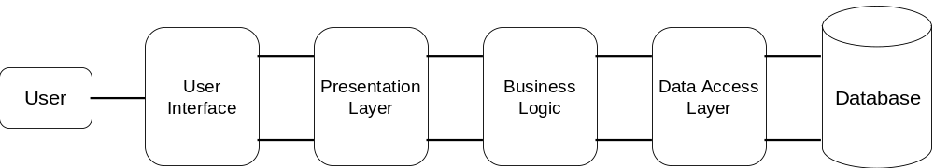
- User Interface: What the user sees.
- Presentation layer:- This layer accepts data from the user and determines how data is displayed. MVC is sometimes described as architecture for the presentation layer.
- Business layer:- Some see the business logic as a bridge between the presentation layer and the DAL and having very little functions, accept for moving data across. The business logic layer should be used if you want to combine data from several tables together.
- Data Access Layer:- The DAL interacts with the database. The DAL carries out the CRUD functions. The DAL must be first and should not carry out any complex business logic. It should be generic and easy to use. If the DAL code is gets to big it maybe a sign that you are actually carrying out business logic in the DAL rather than doing it in the Business Logic.
- Database:- The database used in this application use SQL Server Compact Edition. A connection string must be setup in Web.config located in the root project folder to create an .sdf database file.

7) Models (Class Models / Data Models etc.).
Inheritance is a major feature of Class models in c#. Most of the models used in this application are the data model type. Since we are using the model first development approach the entity classes in our data model inherit from the Entity Object Class and this means our classes aren’t really persistence ignorant.

We had 3 choices when developing the middle tier domain for this application. They were Domain model, Active record or Table model.

The Domain model was used in developing Book Easy application. Using this model we started off totally ignorant of the database. The models used are based on the business requirements of the application and how the data flows. We didn’t use a table model as our database is derived from our models nor did we use active record as the data base would be to the forefront of the application.

One of the major advantages of using the Domain model is that it can handle very complex domain logic. The disadvantage is the difficulty in learning how to use it.

8)Implementation of particular OOP constructs.
This application make good use of C# constructs. The construct is used in decision making in if else or try catch clauses. The constructs used in this application are simple, there’s no nested if else code. This makes the code easy to follow and understand.
The Book Easy application makes wide use of Constructs in the Ingestion of CSV data as it checks the various fields coming in from the external file. It is widely used in our CSVParser.cs and FileReader.cs files. The try catch constructs are used extensively in our DAL’s.
9)Design patterns and architectural patterns implemented in the application.
The Design Pattern implemented was a “Creational “ design pattern called a “Singleton”. A Singleton design pattern is used to ensure that there is a single instance of a class and a global access point to this instance. The class is instantiated once when needed and all requests use this single instance. Also the class itself is responsible for ensuring the single instance constraint.

10) How cross-cutting concerns have been handled.
We examined cross-cutting concerns with aspects of our program and looked at areas that affect the main 3 tiers, Model, View and Controllers. The main areas we looked at were :-
- Logging
- Caching
- Exception Handling
- Security

One of our main concerns was the logging of debug information. We looked at applying global filters. Ideally global action filters should be added to each controller. These filters would give us detailed information about the code how long it took to execute. We could simply add the filter to our account controller to view debug info on the login page. These tools could provide extra info to us while debugging code. It was felt that our learning curve of how the tool worked would out weigh it use in this application.
Caching is an important concern when using any data. While caching is not used as a feature in this project we are aware of the security aspects and all data should be encrypted in cache especially if the application is deployed to the cloud.
Exception handling is important, if done incorrectly it could lead to DOS (denial of service) or leave your application vulnerable to attack. Visual studio 2010 handles exceptions by bubbling up to the boundary layer and if it is not dealt with it throws an exception. The idea is to code in such a way that you reduce the risk of having an exception but also have code there to handle the exception just in case.

11)Security of the application.
In ASP.NET MVC 3 we saw the introduction of global filters. These filters allow you to add the Authorize attribute to the global.asax file. This will protect every action method of every controller. The issue arises if someone codes an action in the account controller that by pass the authorization. This wasn’t an issue with this application as the logon feature wasn’t used.

This application uses forms, the contents of which get stored in the database. We were concerned about the security risk this posed to our data. ASP.NET uses an authentication ticket that gets transmitted between the server and web browser either as a cookie or in a URL string. This ticket is generated at login and it is used throughout the session to identify the user. Forms must be properly protected as it could lead to the following issues.
- Elevate privileges.
- Session Hijacking-Cross Site Scripting, not using SSL, or if the ticket is stored in cache
- Session usage after sign out the authentication tickets lives on until its TTL expires

To protect against these we simply add RequireHTTPAttribute to our global.asax file.
Using web.config opens security risk to the application especially when used in different folders. We could prevent the possibility of cross side scripting attacks by using ASP.NET MVC anti forgery token.
12) Configuration of the application.

We decided to implement the application in 3 tiers MVC3 and then move it into 5 tiers when we had the basic concept working. The MVC3 already had given us the presentation layer so all we would have to do is move some of the controller CRUD into the DAL and create a business layer.

As mentioned earlier in the document the Entity Framework Development Approach we took was model first. We began by creating the various entity classes using three entities,
holiday homes, owners and bookings. There’s a one to many relationship between Owners and Holidayhomes as an owner can be the owner of several apartments. Similarly there’s a one to many relationship between Bookings and Holidayhomes.

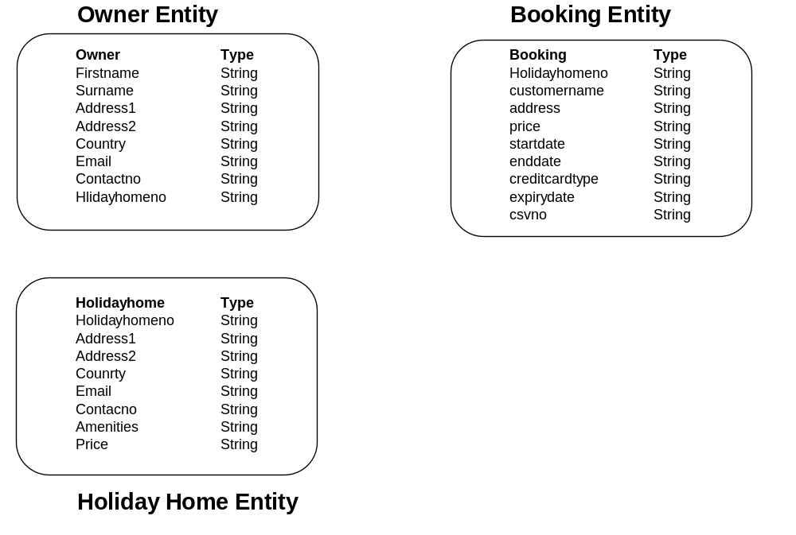
The application was designed using SQL Compact Database. We designed the application totally ignorant of the database and populated with test data using our property initializer. The Entity Framework allowed us to create our property.sdf database when the application ran. If there were any changes made to the model since the last run the Entity Framework will detect this, drop the current database and build a new one.

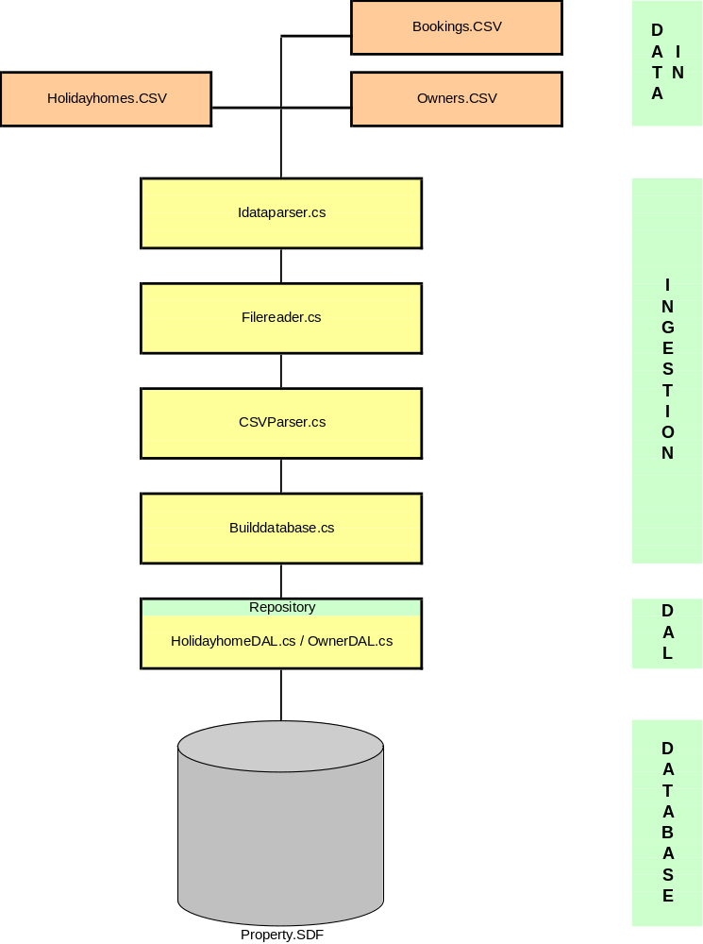

At this stage we have a complete database with using some of our own code but mostly from code written by the Entity Framework due to its use of conventions. The database used in this application is implemented using SQL Server Compact Edition. This database is ideal for storing data locally. This database uses .sdf files and allows you to use database relational capabilities to find information in the database.

Our database context class gives us lazy loading by default. Lazy loading just reads the entities from the database. If the related data is required it must go back and query the database again. With the 3-4 web pages running with basic CRUD, we implemented sorting and a generic search box to the application.

The final development of the backend was to move the CRUD function from the various controllers into the DAL.

The business logic for this application was meant to allow the user scan the list of holiday homes, select one and pay for the holiday home by providing their personal and credit card details. This functionality is not working.

The user gets 4 web page views:-Home, About, Owners and Holiday home page. The Owners and Holiday home page all have CRUD, Search and Sort functions.

13)Scalability of the application.
Software scalability is the ability of a system, network, and process to handle a growing amount of work in a capable manner or its ability to be enlarged to accommodate the growth.
Initially we developed the application as a MVC. If 3 tier architecture was used for this application we would have reduced our ability to scale the application.
This application is designed with the 5 tier approach making the application very scalable.
Moving the CRUD into the DAL using repositories the tiers become more loosely coupled making it more scalable.
Entity Data Structure lets you build and deploy your applications very quickly, but a lot of the data access logic and business logic still reside in the applications .aspx pages. To improve the scalability even more we could implement Object Data Source. If you want a scalable application you need to give more time to developing the front end using Object Data Source.

14) Testing Approach (in terms of both functional and non-functional requirements).
Testing is an investigation carried out to provide to provide stakeholders with information about the quality of the product or service under test.
The purpose of testing is to
- Does the product or service meet the requirements that guided it’s design and development.
- Does the product or service work as expected.
- Can the product or service be implemented with the same characteristics.
- Does the product or service satisfy the needs of stakeholders.
Functional testing refers to activities that verify a specific action or function of the code.

The application was initially implemented using MVC3 and the data was put into the database using our property initializer. Once we had data in the database to work with we began the process of trying to access and manipulate it. At this stage we only had one controller up and running, when we were satisfied that all the CRUD functioned correctly we duplicated our code for the Owner controller.

The site was tested by simulating what the user would use the site for i.e. look for a holiday home by country, sort by cheapest, search for a city etc.

Once we could access the database successfully we began trying to load the database from external sources such as a CSV file. Once the parser got the data into the database we tested the CRUD functionality and navigational abilities of the application.

At this stage some work was completed on the CSS and some pictures were added. The site was checked again to ensure everything was functioning and all images displayed correctly. Any issued were resolved at this stage. Issues requiring further investigation were logged and dealt with at a later stage.

Next the CRUD was moved into DAL repository to separate it away from the controllers. Again the CRUD functionality and navigational abilities of the site were checked.

Finally the Business logic was tested on the site. The business logic failed to work and needs to be examined further.

Non-functional testing refers to aspects of the software that may not be related to a specific function or user action such as scalability or other performance, behavior under certain constraints or security.

Unit Testing
Unit tests should be carried out on all the main tiers of the architecture. The ingestion, DAL, Repositories, Business layer and Controllers require testing. In this application tests were written for the CSV Parser, Controllers and DAL. The unit tests are quick to run and clearly indicate if the tests pass or fail. Some of the tests have failed in this project due to the fact that they are scripted correctly. We know the device under test is working correctly as it is functioning correctly

15)Other relevant features of the application (if used) e.g.,
No other features were included in this application.

In this project, the developed application exhibits most of the traits and qualities associated with an enterprise application. How the qualities of an enterprise level application was achieved is documented. The rationale behind decisions made with regards to the various aspects of the project (eg choice of technology, choice of development methodology and choice of testing strategy) is also documented.
